Initial Database Connection:
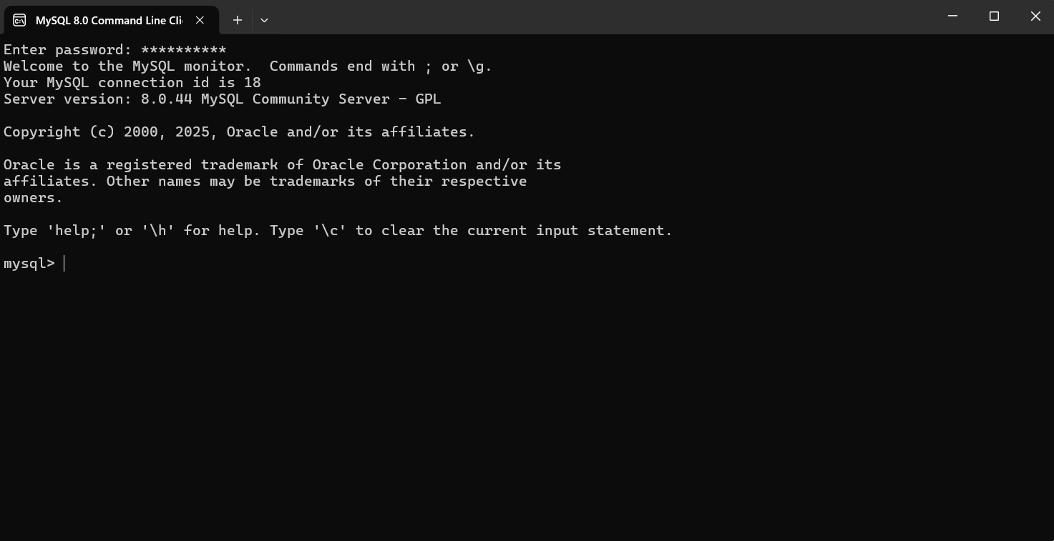

Show Database Command:


Function 1: CONCAT
- This function combines multiple strings into a single string. It can be used to format data for readability. For instance, combining the first and last name to show the full name as a single output.


Function 2: INSERT
- You would use this to insert a hyphen or some other formatting into a set of data or to format the data for output such as on a report.


Function 3: REPEAT
- Repeats a string as many times as specified. Can be used to create a separator line of dashes ‘-‘ or to align certain text. It can also be used with the ‘*’ symbol to mask sensitive data such as card numbers.


